ASSIGNMENT ON TOBOGGAN
STUDENT NAME:
INSTITUTION:
DATE:

Technical drawing for the chute
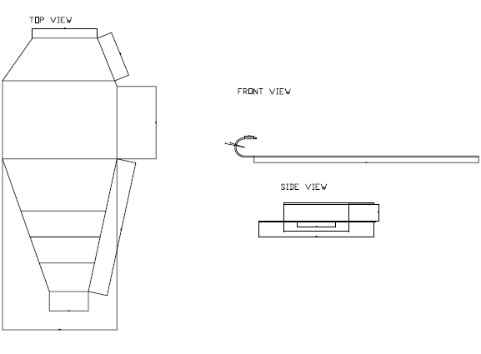

Risk mitigation through design optimization
All toboggans are prone to accidents such as breakage of parts during motion or even overturing of the toboggan mostly in very slopy run ways. To avoid this, the toboggan design has included additional reinforcement to avoid breakages during motion. The toboggan also has ropes which acts like safety belts when one is driving the toboggan. The wooden material which has been used to designed the toboggan is a hard wood which is resistant to crack.

